**Agnim Gupta**

**2028083**

**A-23,CSSE**

**Question 1**

#include <stdio.h>

int main()

{

    int capacity, no_items, cur_weight, item;

    int used[10];

    float total_profit;

    int i;

    int weight[10];

    int value[10];

    printf("Enter the capacity of knapsack:\n");

    scanf("%d", &capacity);

    printf("Enter the number of items:\n");

    scanf("%d", &no_items);

    printf("Enter the weight and value of %d item:\n", no_items);

    for (i = 0; i < no_items; i++)

    {

        printf("Weight[%d]:\t", i);

        scanf("%d", &weight[i]);

        printf("Value[%d]:\t", i);

        scanf("%d", &value[i]);

    }

    for (i = 0; i < no_items; ++i)

        used[i] = 0;

    cur_weight = capacity;

    while (cur_weight > 0)

    {

        item = -1;

        for (i = 0; i < no_items; ++i)

        if ((used[i] == 0) &&

            ((item == -1) || ((float) value[i] / weight[i] > (float) value[item] / weight[item])))

            item = i;

        used[item] = 1;

        cur_weight -= weight[item];

        total_profit += value[item];

        if (cur_weight >= 0)

        printf("Added object %d (%d Rs., %dKg) completely in the bag. Space left: %d.\n", item + 1, value[item], weight[item], cur_weight);

        else

        {

            int item_percent = (int) ((1 + (float) cur_weight / weight[item]) * 100);

            printf("Added %d%% (%d Rs., %dKg) of object %d in the bag.\n", item_percent, value[item], weight[item], item + 1);

            total_profit -= value[item];

            total_profit += (1 + (float)cur_weight / weight[item]) * value[item];

        }

    }

    printf("Filled the bag with objects worth %.2f Rs.\n", total_profit);

}

**Output**

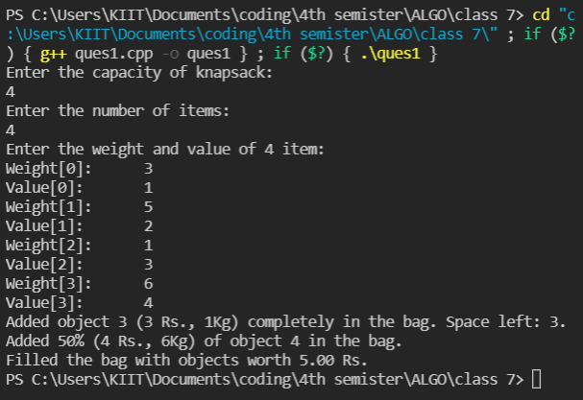

**Question 2**

#include<stdio.h>

int main()

{

    int activities;

    int x;

    printf("enter the no. of activities: ");

    scanf("%d",&activities);

    int start[activities];

    printf("enter the start time: ");

    for(x=0;x<activities;x++)

    {

        scanf("%d",&start[x]);

    }

    int finish[activities];

    printf("enter the finish time: ");

    for(x=0;x<activities;x++)

    {

        scanf("%d",&finish[x]);

    }

    int i, j;

    printf ("Following activities are selected \t");

    i = 0;

    printf("a%d\t", i);

    for (j = 1; j < activities; j++)

    {

        if (start[j] >= finish[i]){

            printf ("a%d\t ", j); i = j;

        }

    }

    return 0;

}

**Output**

